|  |  |  |  |
| --- | --- | --- | --- |
| **Branch: Instrumentation & Control Engineering** | | **Year:** Second Year | |
| **Division: C** | **Roll No: 04** | **GR Number: 11911180** | **Subject:** OOPS |
| **Assignment No: 8** | **Date of Submission: 29-05-2021** | **Student Full Name: Shaunak Sudhir Deshpande** | |

Aim: Write Java program which implements interface.

Software Used: JDK, VSCode

Code:

class NewThread implements Runnable {

    String name;

    Thread thread;

 NewThread (String name) {

   this.name = name;

   thread = new Thread(this, name);

   System.out.println( "A New thread: " + thread+ "is created\n");

   thread.start();

 }

   public void run() {

   try {

   for(int j = 5; j>0; j--) {

   System.out.println(name + ": " +j);

   Thread.sleep(1000);

 }

 }catch (InterruptedException e) {

 System.out.println(name + " thread Interrupted");

 }

 System.out.println(name + " thread exiting.");

   }}

 public class Thread2 {

     public static void main(String args[]) {

     new NewThread("1st");

     new NewThread("2nd");

     new NewThread("3rd");

     try {

     Thread.sleep(8000);

     } catch (InterruptedException excetion) {

         System.out.println("Inturruption occurs in Main Thread");

     }

     System.out.println("We are exiting from Main Thread");

 }

 }

Output:

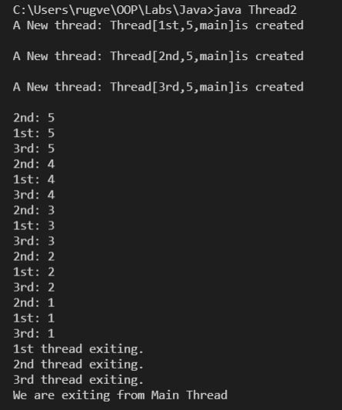

Analysis of Program:

In this class we implement Runnable interface using Java. We also look at the concept of Threads. A thread is a single sequential flow of control within a program.

Conclusion:

An interface in Java is a blueprint of a class. It has static constants and abstract methods.

The interface in Java is a mechanism to achieve abstraction. There can be only abstract methods in the Java interface, not method body. It is used to achieve abstraction and multiple inheritance in Java.

In other words, you can say that interfaces can have abstract methods and variables. It cannot have a method body.